Igniter
Make changes as needed. I still need to add a plumbing diagram, better drawings and a more complete parts listing. - James
Description
The igniter uses a spark plug to ignite an oxygen-ethanol mixture. It consists of a combustion chamber made of aluminum, with fittings for the various inputs and outputs. The current igniter is only 1 5/8" long. This design is bigger to simplify machining operations.
Parts
- 1"x1"x2" block of aluminum
- NGK CM-6 spark plug
- mist nozzle (McMaster?-Carr part number 3178K81)
- 4-40(? maybe bigger) set screw
- brass check valve (McMaster?-Carr part number 5010K72)
- stainless steel check valve (part number 5010K62)
- stainless needle valve (for GOX)
- brass needle valve (for ethanol)
Construction
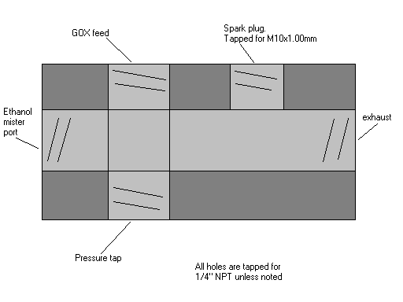
Cross-section view of igniter port geometry.
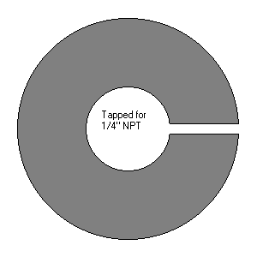
End-on view of "C" holder for misting nozzle modification
- Drill 7/16" hole lengthwise down center of aluminum block, all the way through. Tap both ends for 1/4" NPT.
- Drill a second 7/16" hole 5/8" from one end of the aluminum block, all the way through. Tap both ends for 1/4" NPT.
- Drill a third hole for the spark plug (M10-1.00mm thread), 5/8" from the other end of the block, halfway through. You need something close to a .3583" drill bit for this. Tap the hole for M10-1.00mm. The Edgerton Machine shop doesn't have this tap, but can often borrow it from the machine shop next door.
- Drill hole for set screw (for grounding) in a corner somewhere.
- Put the misting nozzle in a "C" holder, and mount the holder in a lathe. Cut off the hex faces of the mist nozzle. Use a die to cut 1/4" NPT threads on the new surface. Remove the misting nozzle from the "C" holder.
Assembly
- install the misting nozzle into left port on the diagram above. Use 1/4" nipple and flare fittings to connect upstream to: the brass check valve, and then the solenoid valve, and needle valve, and the ethanol supply.
- install a short length of 1/4" nipple into the right hole to connect to your rocket engine combustion chamber.
- install the spark plug in the M10 hole.
- use a flare fitting in the upper NPT hole to connect upstream to the stainless steel check valve, and the solenoid valve, and needle valve and heat exchanger coils for the GOX feed.
- use a flare fitting in the lower NPT hole to connect to a pressure tap, if desired.
Operation
- Open the GOX needle valve 1/4 turn.
Future development
- Order our own M10-1.00mm tap, if we continue to use these spark plugs. (you can get even smaller ones!)
- Try using a snubber instead of the needle valves. McMaster?-Carr has some with orifices in the range of a 100-400 microns.
- Try eliminating the heat exchanger coils
- Test the exhaust flow with an automotive oxygen sensor to confirm that it is fuel rich, especially after many starts or during constant running.
Other igniter projects
- http://www.xcor.com/gallery/15lb
- http://arocket.mid-south.net/group-proj.html
- http://rocketworkbench.sourceforge.net/igniter/igniter_blog.html
- http://www.half-pass.com/felix/simple.html
- http://www.korit.com/tapndrill.htm
-- JamesRobertson - 02 Jan 2005

