Interplanetary Transfer Vehicle Concepts for Near-Term Human Exploration Missions beyond Low Earth Orbit

Arthur N. Guest, aguest@mit.edu

Wilfried K. Hofstetter, wk_hof@alum.mit.edu

Extended Abstract

Introduction and Motivation

This paper presents design concepts for interplanetary transfer vehicles that could be used to carry out deep space missions envisioned by the “Flexible Path” scenario described in the final report of the Augustine Commission [1]. These include missions to lunar orbit, libration points, Geostationary Orbit (GEO), Near Earth Objects (NEOs), as well as a lunar flyby. The focus of the analysis presented here is on interplanetary transfer vehicle concepts which can be realized in the near-term, i.e. by the end of the 2010s or the beginning of the 2020s. The selection of preferred interplanetary transfer vehicle designs is based on a comprehensive integrated performance analysis of mission types and propulsive capabilities.

Ground Rules and Assumptions

The following mission types for interplanetary transfer vehicles are considered: a lunar flyby, a low lunar orbit mission, a mission to GEO, a mission to a Sun-Earth libration point (such as SE-L2), and a mission to a NEO (see Figure 1). All of these mission types can be carried out with mission durations that lie within the US experience of microgravity exposure, yet offer significant benefits with regard to advancing experience with deep-space human spaceflight operations as well as provide relevant science opportunities [2] [1].
3 options for shuttle-derived heavy-lift launch vehicles were considered (see Figure 2): a side-mount vehicle with two 4-segment solid rocket boosters and 3 Space Shuttle Main Engines (SSMEs), an inline vehicle with two 4-segment solid rocket boosters and 3 SSMEs, as well as an inline vehicle with two 5-segment solid rocket boosters and 4 SSMEs; all based on conceptual designs by NASA [3][4]. Vehicles with upper stages based on the RL-10 engine or J-2X engine were not considered because their availability by the end of the 2010s or beginning of the 2020s would be less likely [1].
For in-space propulsion, the upper stage of the Delta IV Heavy EELV and the Centaur V1 upper stage of the Atlas V EELV were considered [5] [6]; furthermore, it was assumed that the Crew Exploration Vehicle (CEV) with its crew module and service module (propulsive module) [7] would be available. For additional pressurized / habitable volume, it was assumed that a crew compartment similar to the lunar lander ascent stage compartment [4] would be available.

Mission Payloads

Figure 3 provides an overview of the payloads associated with the different mission types outlined above. For the short-duration lunar flyby and lunar orbit missions, the CEV itself provides sufficient pressurized volume for 4 people; for the longer-duration GEO, SE-L2, and NEO missions it is assumed that the additional crew compartment would be utilized. Additional payloads are tailored to the specific mission types.

Integrated Performance Analysis

In order to assess the compatibility of launch vehicle, in-space propulsion, and mission payload choices, an integrated performance analysis of in-space propulsion options (differentiated by the number of Delta IH Heavy or Centaur V1 upper stages) was carried out over a range of possible payloads. The results are shown in Figure 4 and Figure 5; payload masses for different mission types as well as LEO-launch mass limits for different launch vehicle choices are highlighted.

Preferred Interplanetary Transfer Vehicle Designs

For each launch vehicle option, preferred interplanetary transfer vehicle designs were selected (see Figure 6):
- For the 4-segment SRB, 3 SSME side-mount and in-line vehicles, using a two-launch architecture with two sequentially mounted Centaur V1 upper stages and the additional crew compartment and science payload on the first launch, and two sequentially mounted Centaur V1 upper stages and the CEV on the second launch is the preferred configuration. The vehicle and spacecraft for the second launch (two sequentially mounted Centaur V1 upper stages and the CEV) can be utilized alone to carry out lunar flyby and orbit missions.
- For the 5-segment SRB, 4 SSME in-line vehicle, using a two-launch architecture with two sequentially mounted Delta IV Heavy upper stages on the first launch, and one Delta IV Heavy upper stage, the additional crew compartment and science payload and the CEV on the second launch is the preferred configuration. The vehicle and spacecraft for the second launch without the extra crew compartment can be utilized alone to carry out lunar flyby and orbit missions.

Conclusions and Further Work

From the above analyses, a number of findings can be derived:
- Significant exploration beyond LEO is possible based on a shuttle-derived heavy-lift launch vehicle with a LEO net payload capability of more than 70 mt, the CEV, adapted EELC upper stages, and an additional pressurized crew compartment (for longer-duration missions).
- The missions enabled by the above elements can provide significant operational experience beyond LEO, provide insight into the effects of the interplanetary radiation environment on humans, and result in sample return from Near Earth Objects.
- These missions require no more than 1-2 launches of the heavy-lift launch vehicle; assuming that the heavy-lift launch vehicle can be launched 4-6 times per year (supported by the record of shuttle launches), 2-3 such 2-launch missions could be carried out each year.
- The integrated performance analysis suggests that more ambitious deep space mission such as Mars flyby missions may be possible given a two-launch architecture using one of the above launch vehicles.

A number of recommendations for future work could also be derived:
- While the above missions are of particular relevance to the Flexible Path scenario, these missions are relevant as initial exploration missions to whatever scenario is chosen for NASA’s future human spaceflight strategy.
- The preferred interplanetary transfer vehicle concepts should be subjected to more detailed design analysis.
- The application of 2-launch architectures to more ambitious deep space missions such as Mars flyby missions should be investigated.
- The analysis should be extended to include other currently available in-space propulsion and habitation assets.

References

[1] Review of Human Spaceflight Plans Committee, Seeking a Human Spaceflight Program Worthy of a Great Nation – Final Report, Washington, DC, October 2009.
[2] International Academy of Astronautics, The Next Steps in Exploring Deep Space – Final Report, July 9, 2004.
[3] Shannon, J., Shuttle-Derived Heavy Lift Launch Vehicle, Presented to the Review of U.S. Human Spaceflight Plans Committee, June 17, 2009.
[4] Exploration Systems Architecture Study Team, Exploration Systems Architecture Study - Final Report, NASA, November 2005.
[5] Wade, M., Centaur website - http://www.astronautix.com/stages/centaur.htm, accessed January 28, 2010.
[6] Wade, M., Delta IV website - http://www.astronautix.com/lvs/deltaiv.htm, accessed January 28, 2010.
[7] Korsmeyer, D., Constellation Enabled Mission: Human Exploration of Near Earth Objects - Technical Assessment Study, NASA Advisory Council Briefing, July 18, 2007.

Appendix

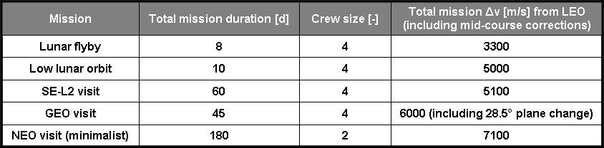
Figure 1: Mission characteristics

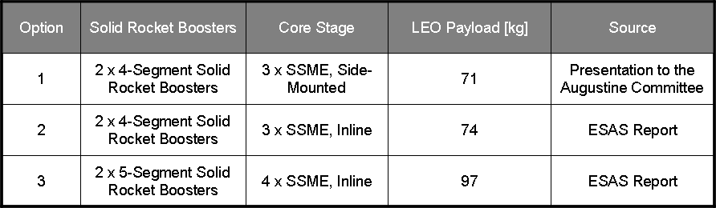
Figure 2: Shuttle-derived heavy-lift launch vehicle options considered in the analysis

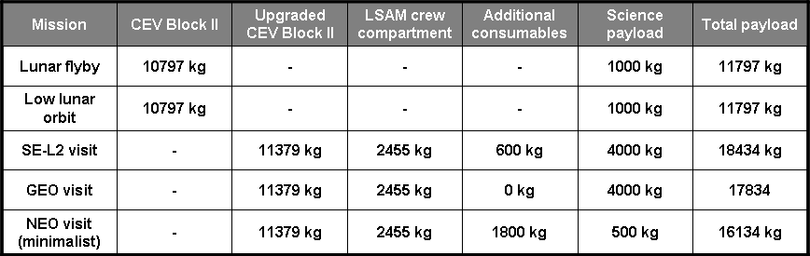
Figure 3: Mission payloads

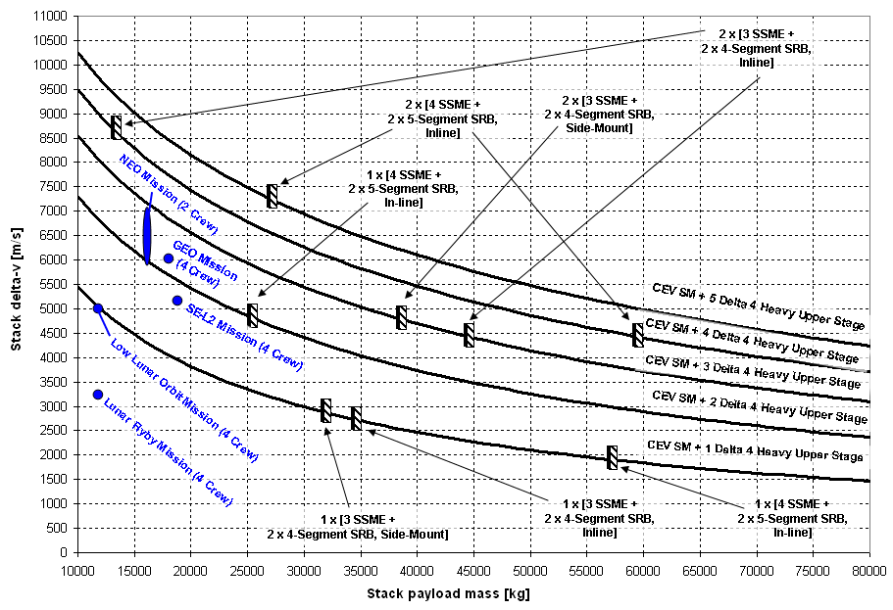
Figure 4: Results of the integrated performance analysis for configurations based on the Delta IV heavy upper stage
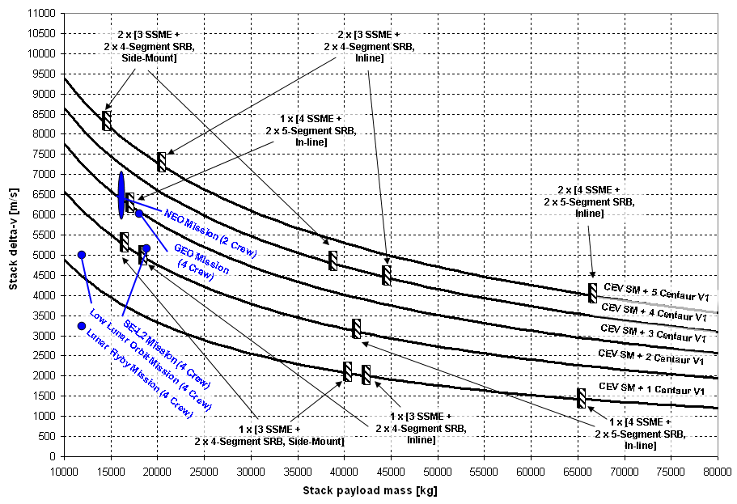
Figure 5: Results of the integrated performance analysis for configurations based on the Centaur V1 upper stage

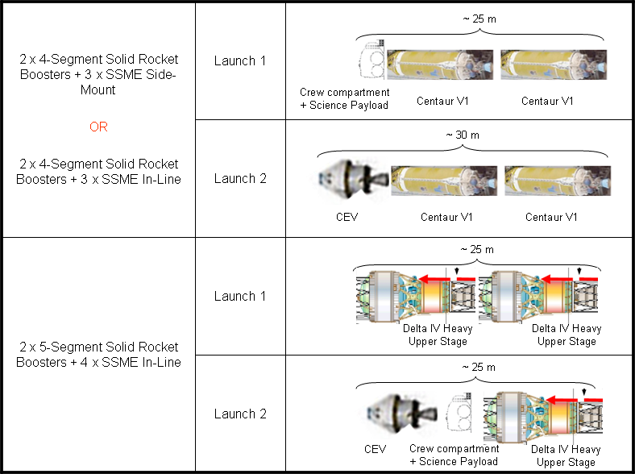
Figure 6: Preferred interplanetary transfer vehicle designs

